Shabbos Stories for
Parshas beha’aloscha 5781
Volume 13, Issue 40 18 Sivan/May 29, 2021
Printed L’illuy nishmas Nechama bas R’ Noach, a”h

For a free subscription, please forward your request to keren18@juno.com
Past stories can be found on the website ShabbosStories.com

The Miraculous
Salvation of Iraq’s Jews
By Elchonon Isaacs
Marking 80 years since the defeat of German proxies in Iraq

Koy Sanjaq in 2012 (photo: Hwnar M. S.)

The following dramatic events, virtually unknown to most Jews, took place 80 years ago this week. This story was adapted from a Hebrew account published by Asher Noach, son of Rabbi Yitzchak Noach, in Sichat Hashavua #533:
In 1941, the German army was spreading its web over Europe, expanding its reach to North Africa and eastwards. The death machine was in full swing anywhere Hitler’s soldiers set foot, and the Jewish people’s sentence was a foregone conclusion.

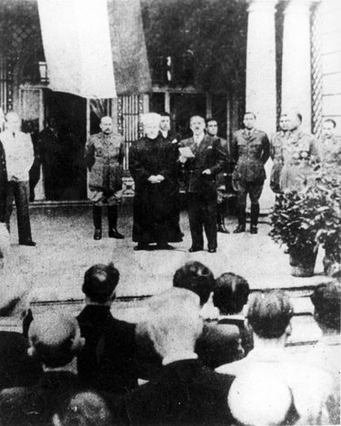
Rashid Ali al-Gaylani at the anniversary of the 1941 Iraqi coup in Berlin.

A military coup erupted in Baghdad during the early spring of that year, in an attempt to overthrow British influence in the region. The uprising was led by Rashid Ali al-Gaylani (1892-1965), an Iraqi nationalist, who acted in full collaboration and support of the Germans.¹
This led to the Anglo-Iraqi War, during which those in the sitting government fled for their lives. The news induced great panic throughout Iraq’s Jewish communities, including the isolated villages in Kurdistan in the north.
As Rashid Ali established his rule, demonstrations against Jews took place in Iraqi cities, often ending in violent riots and looting of Jewish homes and businesses. Jews were imprisoned and tortured on the grounds that they were helping Britain in the war.

Rabbi Yitzchak Noach
Rabbi Yitzchak Noach (1888–1962) was the rabbi of Koy Sanjaq in the Kurdistan region. In addition to his masterful knowledge of Talmud and Jewish law, he was also proficient in the works of Kabbalah. In light of the disturbing events, he decreed a day of fasting and heartfelt prayer in the city’s great synagogue.
The following day, young and old flocked to the synagogue. Their prayers were heart wrenching; the wailing gripping. During the day, terrible news of the riots taking place against the Jews of Baghdad, Kirkuk, and Basra only served to intensify their desperate devotion.
In the evening, after the conclusion of the fast, the community members retired to their homes, deeply worried but hopeful for a miracle.
Meanwhile, the leaders of the community of Koy Sanjaq and the surrounding villages went to the home of the rabbi and begged him to intercede On High to have the terrible decree annulled.

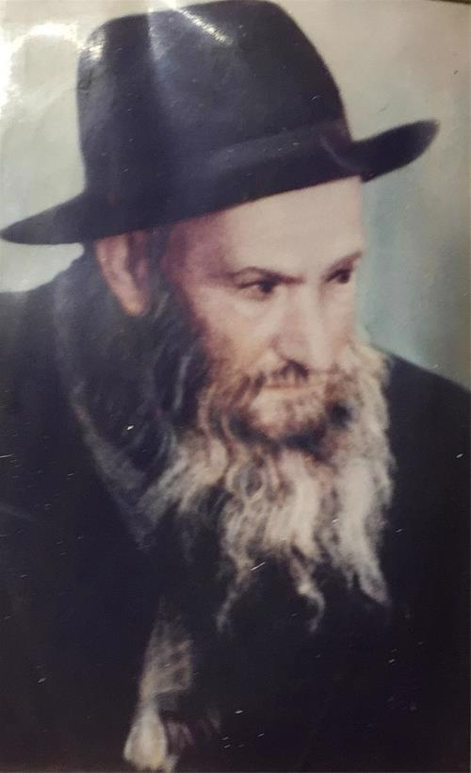
Rabbi Yitzchak Noach

Rabbi Yitzchak Noach responded, “Do you think I’m not doing everything within my power?” After a pause, he continued. “You keep praying through the night, and I will do whatever I can as well.”
The leaders returned to the synagogue and continued to pray and recite Psalms. Rabbi Yitzchak Noach remained at home and continued storming the heavens. At about midnight, he began preparing himself to go to sleep. He immersed in a mikvah in preparation for the Kabbalistic practice of shaalot chalom, whereby one requests Divine assistance through a dream. Rabbi Yitzchak Noach wished to learn the future of Rashid Ali’s uprising and the future of the Jews in the country.

Awoke in a Sweat
Before dawn, he awoke in a sweat and the words of Psalm 37:10 flickered before him: “A short while longer and the wicked man (rasha) is not here, and you shall look at his place and he is not there.”
The general message of the verse seemed hopeful, but the rabbi wished to learn why this specific verse was shown to him. He locked himself in his room and began pondering what hidden meaning was embedded in the verse.
When the time for the morning prayers came, a faint smile was detectable on Rabbi Yitzchak Noach’s face. He noted to those in his inner circle, “The word rasha in the verse are the initials of Rashid Ali. However, I still do not have the full meaning of the verse.” After the morning prayers, he returned to his room and continued to meditate.
Only in the late afternoon did he emerge, his face aglow and full of hope. “I think I have figured out what the verse means in this context! The
word for ‘a short while,’ me’at, is an acronym for mem tet omer, meaning on the 49th day of the Omer, the day before Shavuot, the decree will be done.”
And indeed, on May 30th, the 48th day of the Omer, Rashid Ali and his allies fled to Germany, via Iran.
This did not mean that life went back to normal for Iraq’s Jews. Far from it. In fact, June 1st and 2nd, the two days of Shavuot, were marked by anti-Jewish rioting, murder, and maiming. When all was said and done, more than 180 innocent Jews had been killed, 1,000 had been injured, and more than 900 homes had been destroyed.
Yet, the existential threat embodied by Germany and her Arab sympathizers had been removed with the flight of Rashid Ali, giving new meaning to the second half of the verse, “... you shall look at his place and he is not there.”

FOOTNOTES
1. On May 25, Hitler issued his Order 30, stepping up German offensive operations: “The Arab Freedom Movement in the Middle East is our natural ally against England. In this connection, special importance is attached to the liberation of Iraq ... I have therefore decided to move forward in the Middle East by supporting Iraq.”

The Exceptional Concern
For a Summer Camper

Rav Yoel Gold relates the following story. It was the first day of the new season at Camp Machanayim, and the counselors had gathered for their annual staff meeting.
Following the usual safety speeches, division head Eliav Friedman stood up to make the same announcement he had given the summer before, and the summer before that, stating that if any counselor were to notice a camper who looked homesick, left out, or just sad, he was to approach the boy and talk to him, buy him a treat from the canteen, and make him feel included.
He told the staff, “When I was a camper in Camp Morris, I was having a hard time. I was homesick. There was one guy, Ezry Fireworker, who looked after me. He played catch with me and schmoozed with me, and gave me the time of day when no one else cared. He made me feel like there was nothing he would rather do than play with me. It absolutely changed my summer.”
Eliav now pays his debt forward by putting his staff on the lookout for other such children. Hearing a personal story like this helps the staff appreciate the power of a simple gesture.

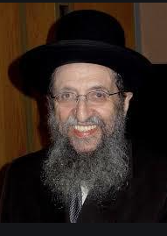
Rabbi Shmuel Kamenetzky

The owner of Camp Machanayim, Rabbi Goldstein, had heard this story before, but this time he was inspired to do something. What an impact that counselor had had on Eliav so many years ago! And what an impact he was indirectly having on all the children who passed through Camp Machanayim’s gates!
Rabbi Goldstein called Camp Morris and tracked down Ezry Fireworker, now some 15 years older. He couldn’t wait to recount the story and share with Ezry the far-reaching results of his kindness. He called Ezry Fireworker, introduced himself, and told his story.
Ezry listened quietly. “To be honest,” he said, “I don’t remember an Eliav Friedman.” Rabbi Goldstein was disappointed, but Ezry went on. “I don’t remember his case specifically because I did this all the time in Camp Morris. “When I was a kid in Camp Agudah, my grandmother was rushed to the hospital one Friday afternoon.
“My family couldn’t talk to me. I was worried and all alone, and I was terribly homesick. Then someone took interest and asked me what was wrong. Even though he was busy and I knew it, he spent time comforting me. I knew what a small gesture and some personal attention could do for a camper, so as a counselor, I made sure to look out for kids like that.”

Another Link to
The Cycle of Chesed
Rabbi Goldstein couldn’t believe it. Another link in a beautiful cycle of Chesed. He said, “Wow. That’s amazing! Who was it that spent time with you?” Ezry told him that in Camp Agudah in the 1980’s, it was common for Roshei Yeshivah to come to camp for Shabbos in order to provide the campers with living role models of what it meant to live a Torah life.
He said, “One Shabbos, Camp Agudah’s guest was Rav Shmuel Kamenetzky. It was he who spotted me as a sad young boy on the sidelines. He noticed me,” Ezry
explained, the memory still making him emotional all those years later.

“He invited me into his bungalow, told me that everything would be okay, talked with me for a few minutes, and gave me a treat.” It was that concern for every child that Ezry later sought to emulate as a counselor. It was that concern that he displayed toward young Eliav Friedman so many years later, and it was that concern that Eliav encouraged his staff to show the campers!

Reprinted from the Parshas Beshalach 5781 email of Torah U’Tefilah (compiled by Rabbi Yehuda Winzelberg.)

Words to Live By

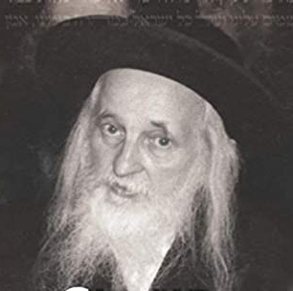
Rabbi Yoel Teitelbaum

A woman living in New Jersey became seriously ill. There was a certain machine available in New York which could help alleviate her condition, but it was expensive to use. She could not afford the cost on her husband’s meager salary, and their New Jersey insurance company would not cover out-of-state treatment.
People told the couple that if they gave a New York address and switched to a New York insurance company whose policies did cover use of this machine, then they would not have to pay. There was not much danger that the company would investigate whether they indeed lived in New York.
They were reluctant to proceed with a falsehood, even if the treatment was life-saving, but a friend insisted, “You are required to use that address! This is a question of life and death!”
The woman was still reluctant to benefit from a lie, saying, “We have always been completely honest; shall we now save my life with a lie?” She and her husband decided to consult Rabbi Yoel Teitelbaum, the Satmar Rav. Upon hearing the question, he asked incredulously, “You would say a lie?”
“But it is a question of pikuah nefesh, saving a life,” the man said.
“Do you mean to tell me that people die in New Jersey and in New York they live? It’s impossible! I am sure that if you are faithful to the truth you will find that you can make use of the machine.”
The man investigated further and discovered that there was indeed such a machine in a certain hospital in New Jersey. His wife was treated there and cured. (Gut Voch by Avrohom Barash)

Reprinted from the Parshat Toledot 5781 email of Shabbat Shalom from Cyberspace (edited by Rabbi David Bibi).

The Rav and the
Bar Mitzvah Boy

Rav Yaakov Kamenetzky once attended a bar mitzvah where the bar mitzvah boy had a difficult time with the Torah reading. In the middle of the reading, for a personal reason Rav Yaakov had to briefly leave the shul.
When Rav Yaakov returned, he was asked if he wanted the portion to be read again from the point where he had left. Rav Yaakov declined this offer, explaining that he was concerned that the bar mitzvah boy would think that the portion was being read again because he had read poorly.
Rav Yaakov continued: Krias Hatorah (the public Torah reading) is a Rabbinic mitzvah, but the requirement that we not cause hurt or embarrassment to our fellow Jew is mandated by the Torah. It would be wrong to violate a Torah mitzvah in order to fulfill a rabbinical mitzvah. (From Table Talk + Mitzvah Dilemma), a parsha sheet (www.achim.org)

Reprinted from Parsha Achrei Mos-Kedoshim files of Parshasheets.com

The Tears of the
Chofetz Chaim
By Shloimy Weber

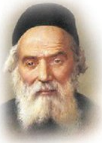

The Yeshiva of the Chofetz Chaim, OB”M, was in dire financial straits. The Chofetz Chaim visited one of Russia’s wealthiest Jews to ask for help. This man owned a number of large factories, some of which operated on Shabbos. The wealthy man was moved by the Chofetz Chaim’s request and immediately gave him a very large donation. When the Chofetz Chaim saw the sum the man had contributed, he burst into tears. The wealthy man was distraught and pleaded: “Rebbe, I’ll give you more money, but please stop crying!”
“It’s not the size of your donation that’s causing me so much anguish,” responded the Chofetz Chaim. “What pains me so is that a Jew like you, with such a good, kind heart, will have to suffer in Gehinnom because of violating Shabbos!” Deeply moved by the Chofetz Chaim’s sincere pain for his lot, the wealthy man gave his word that he would close all his factories on Shabbos.
Comment: In this week’s Parsha, we learn of the infamous characters Dasan and Aviram, making their debut by breaking out a fight amongst the people. Moshe encountered them, and told them to stop fighting (explaining that just raising a hand to another is considered an Aveirah). If we were in the same situation, what would we do? Let’s make sure to be sensitive enough to Hashem’s honor, like Moshe Rabbeinu and the Chofetz Chaim, and not be bystanders following the false secular “mind your own business” mentality.

Reprinted from the Parshas Shemos 5781 email of Torah Sweets Weekly (edited by Mendel Berlin).
Explaining a Tragedy
By Rabbi Sholom DovBer Avtzon

Rabbi Sholom DovBer Avtzon

Last month, we were all pained from the horrific tragedy that befell Klal Yisroel, in Meron. Rabbi Shimon bar Yochai who symbolizes life, and whose name has the numerical equivalent of mechayeh hameisim (bringing life to the dead), and on his day of celebration, at his burial site, such an unimaginable event can occur.
When I replied to those who reached out to me for an explanation, that we have to have faith, and it is something that can’t be explained, some of them replied, Rabbi, sorry to say but that is somewhat of a cop out. I will now try to explain why it is an answer and not a cop out. Your feedback is always appreciated.

The Completely Non-Religious Israeli Jew
This week, someone forwarded to me the following story.
There was an Israeli Jew who was completely non-religious. For some reason he “happened” to be in New York for Tishrei and his host was the Rebbe’s secretary, Rabbi Binyomin Klein.
Although he never kept Yom Kippur, out of respect for his host, he refrained from eating or drinking, and came into the shul to see what religious people do on this solemn day. Being that he was an Israeli, and fluent in Hebrew, he had a machzor with him, and was following the prayers.
When the chazzan came to the repetition of the Musaf tefilah, and began chanting the story of the Ten Martyrs, he couldn’t contain himself, and demanded from those next to him to explain the answer that G-d Almighty gave the angels.

Hashem’s Response to the Angels’ Protest
The angels protested. Is this the appropriate reward for those who devoted their entire life and essence to learn and teach Your Torah?! Hashem replied, be quiet and accept it, or else I will revert the world to nothingness! What type of answer is this, the man inquired? Finally an entity has the courage to ask, but where is the answer?
Most people replied to him, we don’t understand it, but we have faith that Hashem who is our Creator understands better than we. However, the person was not placated by this explanation, he demanded an answer.
So the people around him, pointed to an elder chossid, Reb Zushe Wilomovsky (or perhaps to Reb Dovid Chanzin), and said, ask him.
Hearing the question Reb Zushe replied:
There was a king that was making a wedding for his only child. Everyone understands that in general everything in the palace is always on the highest standards of excellence and beauty, but in honor of this momentous occasion, the king demanded that it be elevated to even higher levels, a step higher .
Only the tastiest foods will be served, the servants should seek out the most exotic animals, fish, fowl, and produce. The best musicians would be assembled from the entire country, and so on.

The King’s Offer of Wealth or Lifetime Imprisonment
The king also ordered the finest silk and material for the clothing the royal family would be wearing, and then search for an experienced tailor to custom-make them. The kings’ offer was a generous one, If you make the clothing to my liking, you will be paid enough to live comfortable for the remainder of your life. However, if I am disappointed for whatever reason, you will be thrown into prison and languish there for the rest of your life.
Understandably, almost all the tailors in the town were hesitant to accept such a challenging condition, however, there were a few tailors who were extremely confidant in their expertise who came forward. The King chose a Jewish tailor who had an impressive reputation. This infuriated his advisors, and they said to the king, the Jews are thieves, even if he makes a most exquisite garment and receives the king’s generous payment, that is not enough for him. He is going to steal some of the excess material. After all the material has golden threads and small precious stones in it.
So the king added another condition to the contract, if you are accused by eye witnesses that you stole any amount of the material, you will be killed.
Knowing that he has never held on to any ones excess material, the Jew agreed
Two months later, the tailor brought all the garments and the king and Queen were raving about its luster and beauty, it was beyond their expectations. Even the advisors admitted that they were a masterpiece. The king instructed the royal treasurer to fill up the bags that the garments were brought in with coins and precious stones, as payment to the tailor.

The Wicked Advisor’s Lie to the King
But then one of the advisors said, your majesty, we were told that the tailor held on to two yards of material.
Hearing this, the king was fuming with rage and according to the agreement the tailor was to be put to death. Knowing that declaring his innocence wouldn’t help him, the doomed man simply asked for the garments and a pair of scissors as his final wish.
The king was aghast, the tailor wants to stick it to me. But it wouldn’t look nice if he didn’t grant the man’s final wish, so they were given to the tailor.
When it was brought to him, he began with great care to undo all the stitches and placed the pieces next to each other unfolding all the folds and opening up all the hems. While the king was aghast that the garments were now destroyed, he saw that all the material was accounted for nothing was stolen and spared his life.
Turning to the tailor, the king asked why did you have to undo the stitches, and destroy two months of labor?

The Only Way to Answer the King
That was the only way to answer His majesty’s accusation, replied the tailor. Any other answer I would have given would have been rejected by the so called “eye-witnesses.” But, yes, sorry to say, now there is no garment.
Turning to this Jew, Reb Zushe concluded, Hashem was telling the angels, if you want the answer, I can give it to you, but the only way to do so, is to turn the world into nothingness. Accept the fact that there is a reason.
May Hashem comfort all the families and indeed all of Israel that they should only experience revealed kindness.
Rabbi Avtzon is a veteran mechanech and the author of numerous books on the Lubavitcher Rebbeim and their chassidim. He can be contacted at avtzonbooks@gmail.com

Reprinted from the Parshat Bamidbar 5781 email of Rabbi Avtzon’s Weekly Story.
The Power of Shabbat

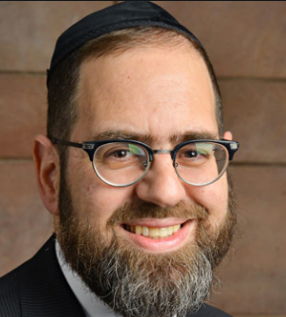

Rabbi David Sutton told a story about a struggling family in Poland in the early 1900’s that decided to send one of their nine children — a 12-year-old girl named Rose — to America, where they hoped she would have an easier life. They managed to save money for a one-way ticket, and her father brought her to the dock.
Knowing this was likely the last time he would ever see his daughter again, Rose’s father said to her, “Rose, remember that Hashem is watching you every step of the way. Remember His laws and observe them. Never forget that the Jewish people have kept Shabbat throughout the ages, and Shabbat will protect you. Things will be hard in your new country, but never forget who you are. Keep Shabbat no matter what sacrifices you will have to make.”

Continued to Observe Shabbos
Rose arrived in the U.S. and moved in with relatives who had abandoned their “old-fashioned” religious lifestyle. They gave her new clothes, a haircut, and she looked like a typical American girl. Nevertheless, she remained faithful to her father’s parting words, and continued observing Shabbat. She got a job, and every week she came up with a different excuse why she could not come to work on Saturday. After several weeks, Rose’s manager figured out what was going on, and called her over.
“I am pleased with your work,” he told her, “but your weekly absences on Saturday must end. Come in this Saturday, or you’ll be looking for a different job.” Rose’s relatives pressured her to go to work to save her job and her parnassah. When Shabbat came, she decided to remain strong. Rather than confronting her relatives, she left the house as though she were going to work, but actually went to a park bench and sat among the pigeons. Rose spent the day sitting on the bench and staring into the sky.
At the end of the day, when she approached the house, she heard her cousin Joe shout, “Rose! Where have you been?” Rose assumed that the family found out she was not at work and were angry at her. She started crying and said, “Joe, what will I do? Everyone will be angry with me!” Joe looked at her and said, “Rose, didn’t you hear?” “Hear what?” Rose asked.

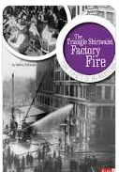

Joe informed her that the factory where she worked had caught fire. This was the infamous Triangle Shirtwaist Factory fire that erupted on Saturday, March 25, 1911. Rose Goldstein was among some 40 of the 190 factory workers who were not killed. Many workers were trapped inside the building or jumped to their deaths. “Don’t you see, Rose?” her cousin said tearfully, “Because you kept the Shabbos, your life was saved.”
Hashem asks us to put our trust in Him every seventh year for shemitah, and every seventh day for Shabbat. From this story, we learn that not only will our livelihood be saved, but our lives as well.

Reprinted from the Parashat Behar-Bechukotai 5781 email of Jack E. Rahmey based on the Torah teachings of Rabbi Amram Sananes.
Sitting in the Front Row
Sitting in the Front Row
Adapted from the teachings of Rav Avigdor Miller z"l
By A. Ben-Ami

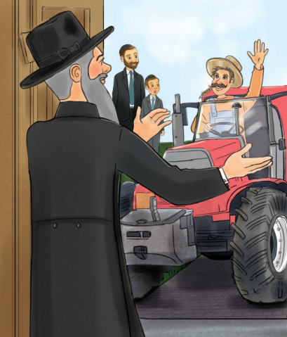
Illustrated by Yocheved Nadell

It was a beautiful spring day as Shimmy and Totty walked to Shul for the Rov’s weekly halacha shiur. The shiur was really meant for adults, but Rabbi Friedman made it so interesting that Shimmy loved going, even if he didn’t understand everything the Rov was saying. He always learned something new and Shimmy already knew more halachos than all of his friends as a result.
As they arrived at Kehillas Bnei Avigdor, a loud rumbling noise made Shimmy look up. To his surprise, there was a big, bright red tractor driving up to the shul entrance! And sitting on top of the tractor, dressed in overalls, was Richard Bazoigenstein, the local farmer.
“Hi Richard!” came a familiar voice from the shul entrance. Shimmy looked up to see Rabbi Friedman waving to the farmer. “I’m so glad you were able to make it today!”
“Hi Rabbi!” said Richard with a big smile, as he parked his tractor and climbed down from the giant machine. “I’m so excited to come learn Torah! And you won’t believe it, but I got all the way up to ‘lamed’ today with my Aleph Beis learning. I know more than half of the letters!”
Shimmy looked on curiously as Farmer Richard parked his tractor and headed towards the entrance. Was he going to the shiur as well? He wondered what someone who didn’t even know all of the Aleph Beis could gain from a shiur like this. They all walked into the shul, and to Shimmy’s surprise, Mr. Bazoigenstein took a seat in the front row, right next to him and Totty.

The Benefit of the Brocha Ahava Rabbah
The Rov handed out photocopies of a tshuva from Igros Moshe and started the shiur. It was a very interesting shiur that talked about how if someone wasn’t sure whether he said birchos haTorah that he could have in mind during the brocha of Ahava Rabbah to be yotzei birchos haTorah. They read the tshuva from Rav Moshe Feinstein inside, and while Shimmy didn’t understand everything the Rov was saying, it was still very fascinating and he learned some interesting things about brachos on mitzvos and how Ahava Rabbah can work as birchos haTorah in certain situations.
A couple times during the shiur, Shimmy glanced over at Mr. Bazoigenstein. He looked confused and most definitely couldn’t actually be following along in the Igros Moshe if he didn’t know any letters past lamed! After the Shiur, as they were walking out of Shul, Shimmy heard Mr. Bazoigenstein talking on his cell phone as he climbed back onto his big red tractor.
“Belinda!” he was saying, “The Rabbi’s class was so interesting! He said we’re supposed to say a brocha for learning Torah every morning! I already knew that, but it was so great to hear it again!”

Shimmy’s Question
On the way home, Shimmy turned to Totty. “I don’t understand something,” he said. “Why did Mr. Bazoigenstein come to the Rov’s shiur? He doesn’t even know how to read and he obviously didn’t understand anything the Rov was saying. And not only that, but he sat in the front row! Isn’t that kind of silly? I mean, I don’t understand a lot of what the Rov says, but at least I understand the main points. But it seems like Mr. Bazoigenstein is just wasting his time!”
“Not at all,” said Totty. Rav Avigdor Miller explains that even if someone doesn’t know any Torah or how to learn, but just by the fact that they come to a group of Torah learning, that gives them a cheilek in Olam Haba. Rav Miller says this means it is a zchus to sit in the front, to show that Torah is so important to you that you want to be in the front row, that you want the kavod of being in the front when it comes to Torah.”
Shimmy smiled. Totty was talking about Farmer Richard, but it also made him feel good to hear this, that he was getting schar for coming and sitting in the front row of a shiur, even though he didn’t understand everything the Rov was saying.
But Totty continued, “Shimmy, it is important to remember, though, that as great as it is to go to a Torah shiur and sit in the front row in a shiur, but that’s not enough. To really be in the ‘front row’ means to be someone who makes Torah the most important thing in his life. By devoting your life to learning and understanding the Torah, we will be zoiche to really sit in the ‘front row’ in Olam Habah.

Reprinted from the Parshas Bamidbar/Shavuos 5781 email of Toras Avigdor Junior.

1840 Circa Silver
Torah Crown
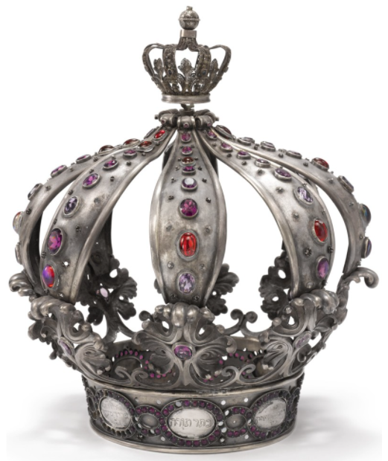

Reprinted from the 2020 Sotheby’s Judaica Auction Catalogue. The Torah Crown sold for $4,410

